#1. sent the PRHS request to room ops stage

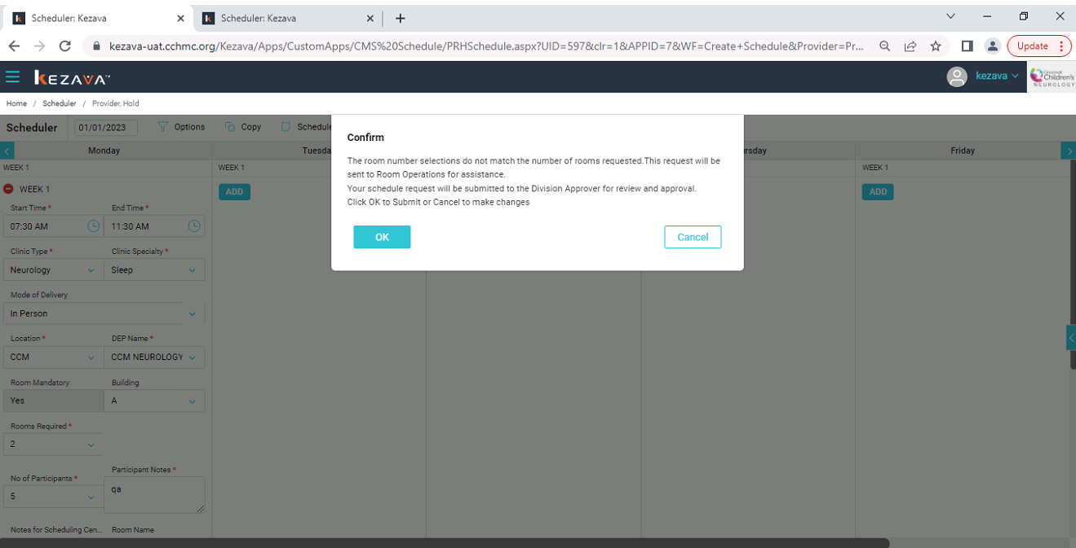

#2. Schedule saved successfully in the request stageGraphical user interface, application

Description automatically generated

#3. ERF Exam 212 room is operational Hold

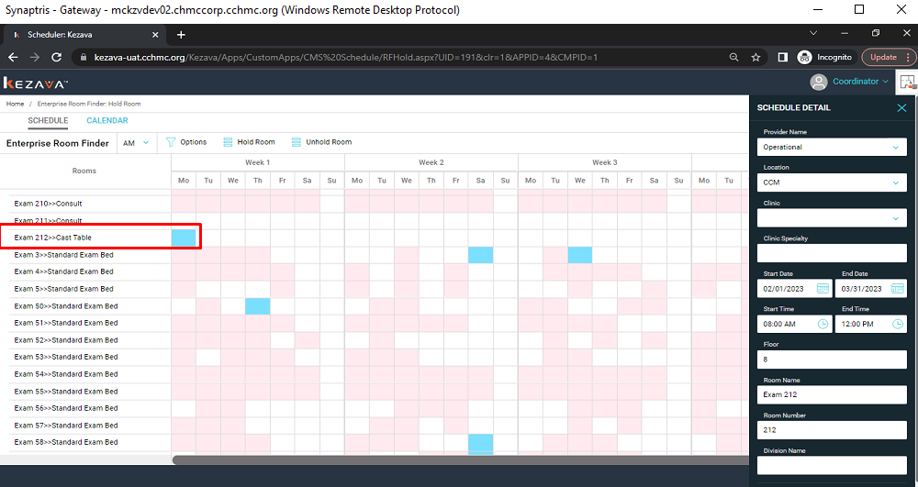

#4. Exam 212 room selected and save schedule got hard block

#5. Again, go to RF page and click save button with “Exam 212” got 20% alert

#6. Save the schedule from room ops

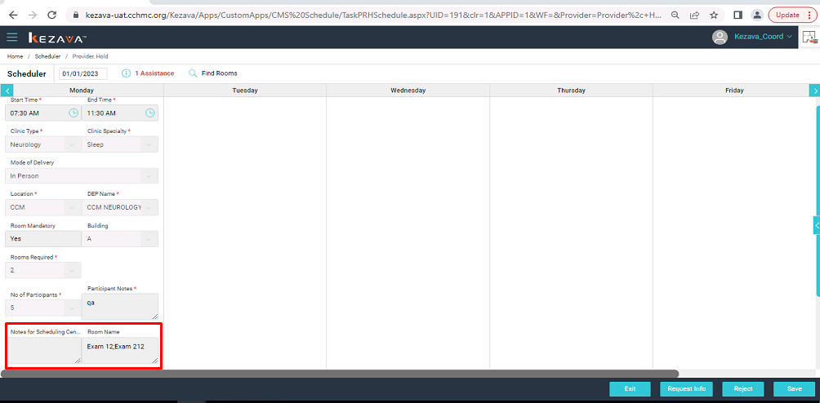

#7. Complete the PRHS schedule

